# CS 515 Homework Worksheet #3

|  |  |  |  |  |  |  |
| --- | --- | --- | --- | --- | --- | --- |
| Name: | Ryan J. Skelly | UNH User ID: | 988977861 | Total: |  | /100 pts |

Lecture Section: 02 (circle one)

## Part 1: Binary Search Trees **[50 pts]**

1. 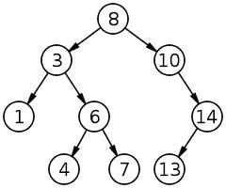Traverse the BST at right in the following orders:
   1. **[6 pts]** In-order (depth-first)

1, 3, 4, 6, 7, 8, 10, 13, 14

* 1. **[6 pts]** Pre-order (depth-first)

8, 3, 1, 6, 4, 7, 10, 14, 13

* 1. **[6 pts]** Post-order (depth-first)

1, 4, 7, 6, 3, 13, 14, 10, 8

* 1. **[12 pts]** Breadth-first

8, 3, 10, 1, 6, 14, 4, 7, 13

1. **[20 pts]** Draw the BST (given above) as a right threaded binary search tree with a dummy root node—whether you modify the existing diagram or draw your own, please be neat to ensure full credit. What is the advantage of having a tree right-threaded?

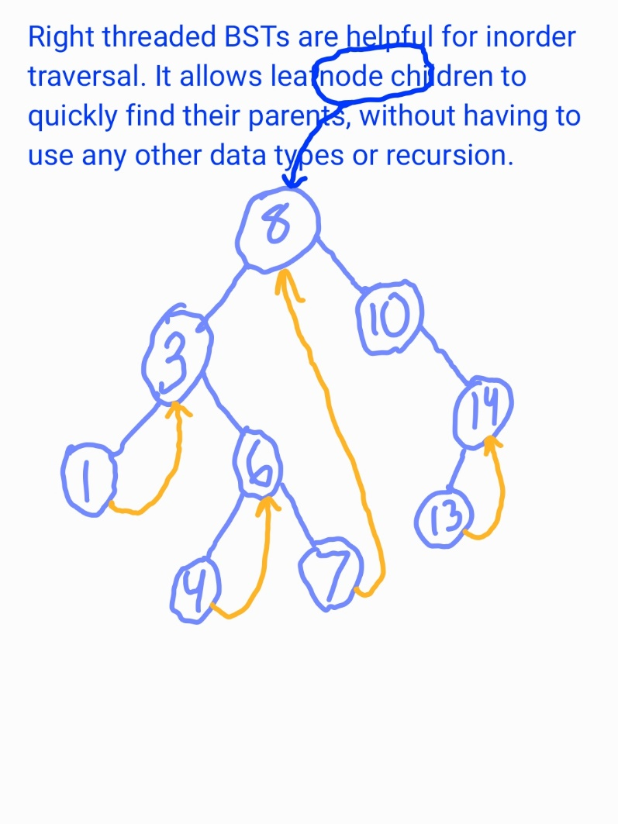

## Part 2: AVL Trees **[50 pts]**

1. 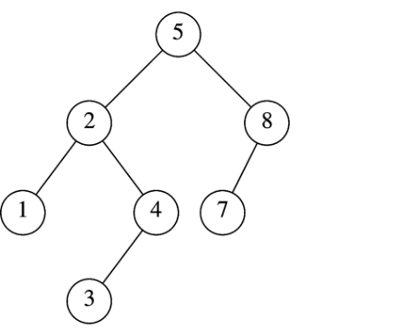**[30 pts]** Insert the values 6, 15, and 9 into the AVL tree shown at right. Show the resulting tree after each step.

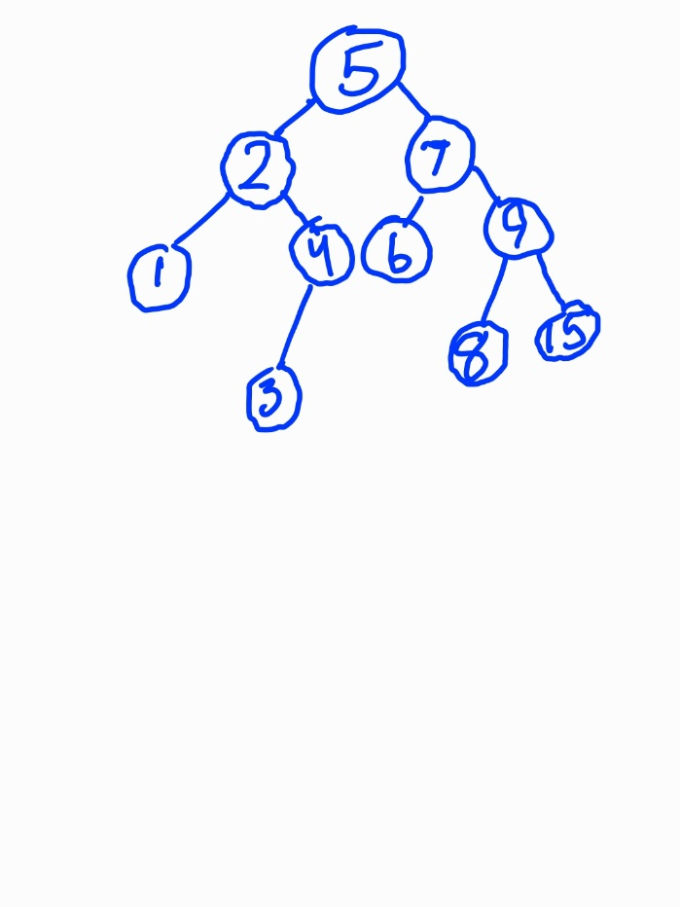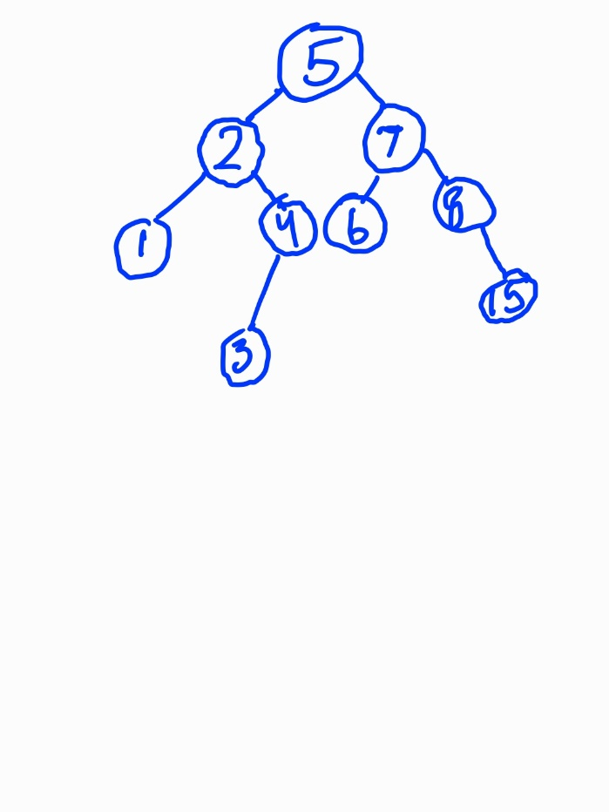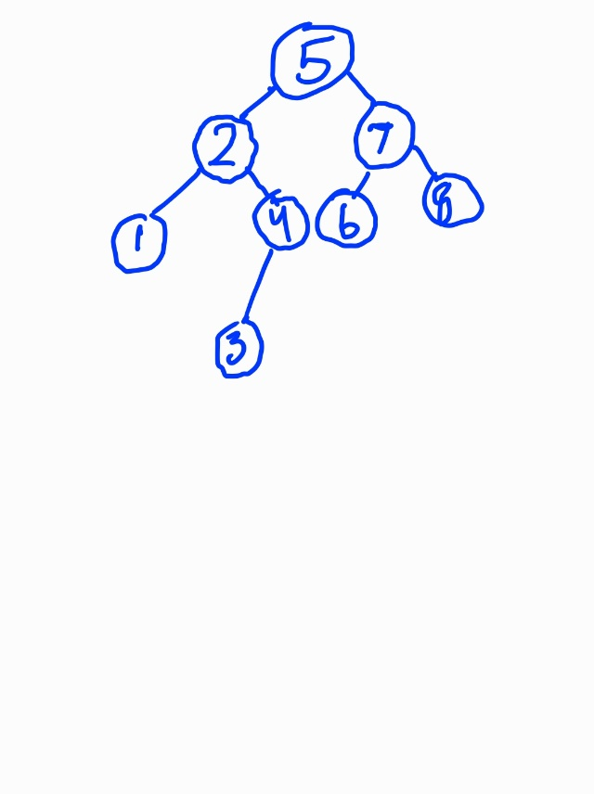

1. **[20 pts]** What rotations would be required to rebalance the tree (shown again below) after removing the node with a key value of 7? Indicate the root-node of the rotation and the direction for each.

